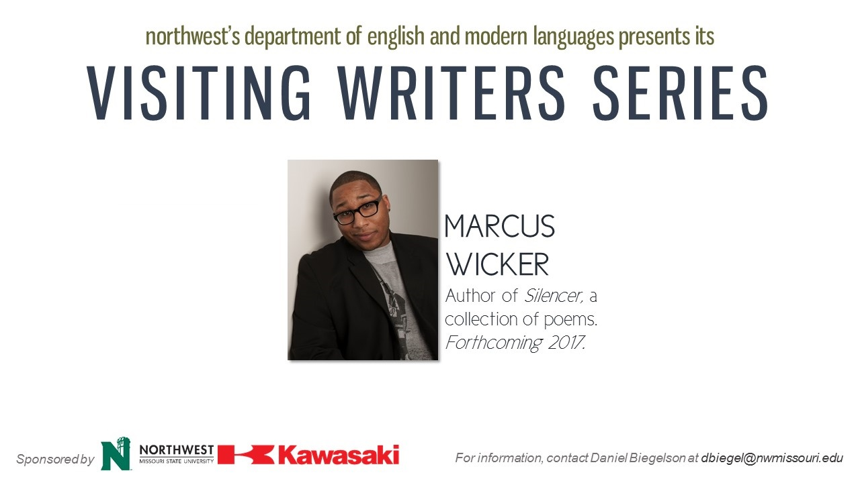

Marcus Wicker Interview-10/7/2016

*This interview was done by Reid Latimer and transcribed by Ashley Hawkins.*

On the behalf of the Visiting Writer’s Series at Northwest Missouri State University we bring you poet Marcus Wicker. Marcus is the author of *Maybe the Saddest Thing,*which was selected by poet DA Powell for the national poet series. His second book *Silencer*will be released fall 2017. Wicker is the recipient of the Pushcart Prize and has fellowships from Ruth Lilly, Cave Canem and The Fine Arts Works Center in Indiana University.

**RL: One of the things that I wanted to talk to you about in your poetry is that it seems like through a lot of your work---and you talked about this last night with the *Silencer*poems---the topics that silence us as observers of the poetry or just even subject matter that might silence us. It made me think of this article I was reading in which there was dialogue between James Baldwin and Chinua Achebe. Achebe says, "Art is unashamedly, un-embarrassingly, if there is such a word, social. It is political; it is economic. The total life of man is reflected in his art." And it occurs that there's some pretty awful things that happen in the world in which we live. If the aesthetic is generated by the world in which we live, how important is it to include those sorts of things that are blatantly political, blatantly violent, blatantly economic in those ways that we may not usually think about poetry being?**

MW: Yeah, I mean the quote from Achebe sort of reminds me of the 1920’s debate between DuBios and Alain Locke. The idea of art for social protest or propaganda, or art for art sake, and I guess I'm a believer of both. I think both are viable options for me during this day and age when you know the last several years you’ve seen publicly televised shootings of black individuals by police officers, and you know when I look at CNN and MSNBC and I see the same stories sort of scrolling across a news ticker; feels like I gotta speak up and say something. I've gotta do my part for social justice, and so for me, the poems are a way of doing so. I can't speak for everyone else, but it's easier for me to sort of hash out an argument on the page than to talk back and forth to someone. So those poems in the reading last night, I started writing the poems because I have this group of friends---and good friends right, we'd always have these crazy debates about all these topics under the sun, but whenever we talked about gun violence it got real quiet. Sometimes people purposefully changed the subject matter, so I felt like I was being silenced. The *Silencer*poems for me work for a slight of hand: they show you one thing and then they sort of pull the rug from under your feet. It's my hope that without mentioning the actual names of the victims or too many details, like the silence in the poems themselves, will be uncomfortable enough to sort of hurt you more so than rhetoric, more so than talking directly.

**RL: Have you shared any of you work that's going to be in this book with any of that group of friends?**

MW: I have, and so it's interesting. They're all pretty literate---they're all literary folks as well---they're readers and so without me even having to send them poems they've seen them published in magazines or on Facebook, and after dialoguing with me and me admitting you were sort of the impetus for some of these poems. It's been a good conversation starter. It's opened up a dialogue between us in a way that I think is more productive than me just saying, “Hey, it really hurts my feelings when you do this.” I don't know why, but it happens. It's made a difference for our relationships even.

**RL: In the development of those sorts of poems, has it become an increasingly more difficult project in the sense that the world in which we're living seems like you might have to write another one of those *Silencer*poems once a week? How do you reconcile that sort of writing about the world you live in, but the world you live in is a thing where it's repeating itself biweekly?**

MW: That's the good thing about literature: once it's out there it's out there. Once the poems are published, once the books are published, those arguments happen absent of me. So, in my mind, once the *Silencer*book comes out, hopefully, I won't have to repeat the project again. That's the purpose of the book.

**RL: You talked also a little bit earlier about art for art’s sake, and also art as being political, or art as maybe being a form of activism. I've noticed in your work especially that it's pretty obvious reading your poetry that the music of the line itself is something that's important to the work. I'm curious: has it always been that way, or is that a tool you've sort of realized that you have that you can utilize? How important is the musicality of the line for bringing in people that might not be necessarily taking apart lines and line breaks and things like that? It's just your lines are catchy to the ear. How important is that?**

MW: When I started writing poetry it was initially performance poetry, and it's because I was interested in sounds, so lots of my poems would play with rhymes, slant rhymes, end rhyme, and internal rhyme. I've always been a child of hip-hop. I don't think anyone who's listened to rap, like you, could lie to me and tell me you've never tried to kick a rhyme, right? But I wouldn't believe you. So that's where it started for me. There's been times in my writing career where I've tried to go away from that because I think there's a way that hip-hop (because it's attached sometimes to misogyny and a lot of problematic elements) that it can be dismissed, but I can't escape those polyrhythms. I was sort of raised with music, so when I write a poem initially I'm talking it out like I would drive you crazy if you were my roommate or something because I'm talking these poems out. I'm saying them repeatedly, and so I'm always thinking about the way an audience might hear a poem, but also once I transpose the poem from the paper---and that's where I usually start---to the computer it's like an initial revision. I'm re-seeing the line. So you could break a line to create double meaning; you could break a line to surprise a reader, but for me I'm surprising myself, and so line break is a tool for me to write poems that I don't already know. I'm surprising myself once I transpose from the paper to the computer. I'm re-breaking my lines two times in a draft. So it's really a tool of invention for me more so than anything else.

**RL: When you're writing those lines you say sometimes it changes from the paper to the computer. Is that because the breath and the cadences are different when you're actually speaking it---you realize it needs to be a certain way---or are you saying there's multiple levels on which the cadence and the rhymes are working?**

MW: Both of those things, but I'll also add that I've been interested in scansion lately, and so a lot of the poems in *Silencer*like Kendrick Lamar and Logic and this rapper named Oddisee. It's like that boom back shit like that rappity-rappity stuff, and I like that. So sometimes I'll scan a line or two from their songs that I like, and because I like the cadence so much, I'll try and repeat that over and over again in a poem just as a way in.

**RL: In the technology rich world we have all these different platforms to put poetry on. We have Soundcloud, people on their YouTube channel, and just all sorts of poets doing it themselves. How do you find that kind of poetic diaspora of everyone spreading out and poetry being in all these different platforms, on all these different levels? Do you notice if that's doing anything to poetry? Is that changing the landscape of poetry at all?**

MW: Absolutely, I think that it’s helped poetry spread a little wider than it has been in the past. I think that there's this way we think of poetry as classist, or we think that if you don't have a certain level of education that poetry isn't accessible to you. That's just not the case, so using multiple platforms like YouTube, like Soundcloud, like Rap Genius or Poetry Genius you're allowing access to people who didn't know they were allowed or permitted to even like poetry, and so that's been exciting for me to say. And poets nowadays, some of them are rock stars like you think of this guy, Ocean Vuong---this awesome poet---one book that just made this huge smash in the world of poetry. He's a fantastic poet, but also he's using multiple medians to reach out to people. So yeah, I think it's beautiful. It's a good thing.

**RL: I know you said in another interview that you started hanging out with a lot of poetry people and you realized it was a very inward facing group. So, along with the diversity of platforms and the dispersion of poetry throughout all sorts of different platforms online, how does the music or the references that you bring to your poetry---intentionally or unintentionally---how does that bring people into your work? Do you find that’s something you do consciously or is that just a result of who you are as a poet?**

MW: I think it's dangerous if you entered into a poem thinking about an audience. That shouldn't be your first intention. I'm sort of true to myself these days, true to the sound of my own voice, and that sound varies so primarily I'm thinking about that more than anything else. I do think by having a diversity of subject matter it does attract multiple groups, and that's great I think for poetry in general. So if that means that when I use a poem using a hip-hop reference or a pop culture reference or something like that it gets me more love. Ultimately, it gets poetry more love. I'm all about that.

**RL: Is there one poet, one musician, one song, or one thing on your mind that you're listening or reading a lot that you just want to give a shout out to?**

MW: The MC I mentioned, Oddisee, the guy from DC. You should go check out his work. He raps in English, and he can also rap in Arabic. The topics are pretty conscious, but also he can sort of speak to the everyman as well, and just someone who is a social activist doesn't get nearly as much love as I think that he should. A good song I think anyone might love of his is called “That's Love.” Worth checking out.

**RL: Marcus Wicker, poet, *Silencer* coming September 2017. Thanks so much for being here, Marcus.**

MW: Appreciate it. Thank you.